**CIDM 6355 LA2 Submission**

(20 points in total; Due 11:59pm CST, September 3, 2023)

Your name: ________________

**Part 1 A Screenshot of Statement of Accomplishment** (you should receive a copy in your email as well) to show that you have completed “Introduction to R” **or** “Introduction to R for Finance” **(14 points). Please make sure that your Statement of Accomplishment meet all the requirements specified in LA2 Instruction.**

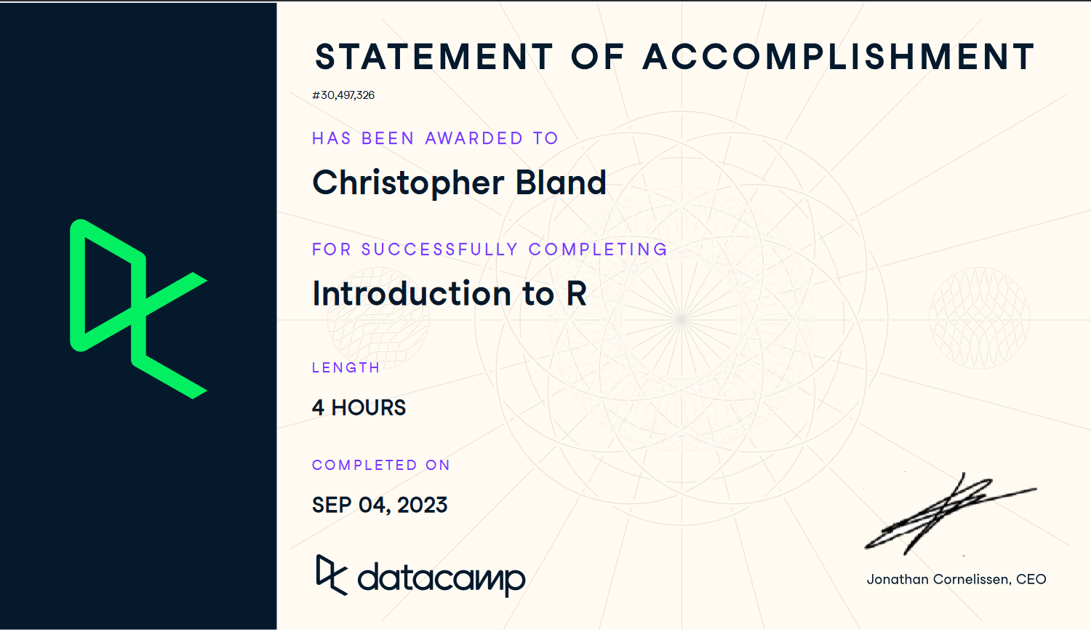

**Part 2 RM Preparation Practice (6 points).**

1. A screenshot of your **RM process** with date and time and briefly (1 sentence preferred) describe what the dataset is about (1.5 points for Screenshot and 1.5 points for your description). **Please make sure that your screenshot includes date and time.**

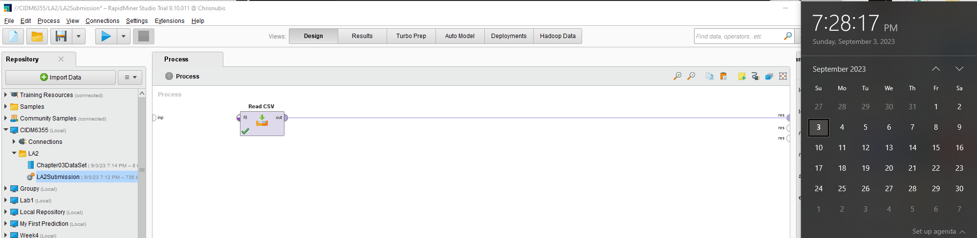

**Description: Statistical user data on internet preferences and usage based on a variety of factors among 11 internet users.**

1. Take a screenshot of your visualization in RM with date and time and briefly describe what the visualization is about (1.5 points for Screenshot and 1.5 points for your description). **Please make sure that your screenshot includes date and time.**

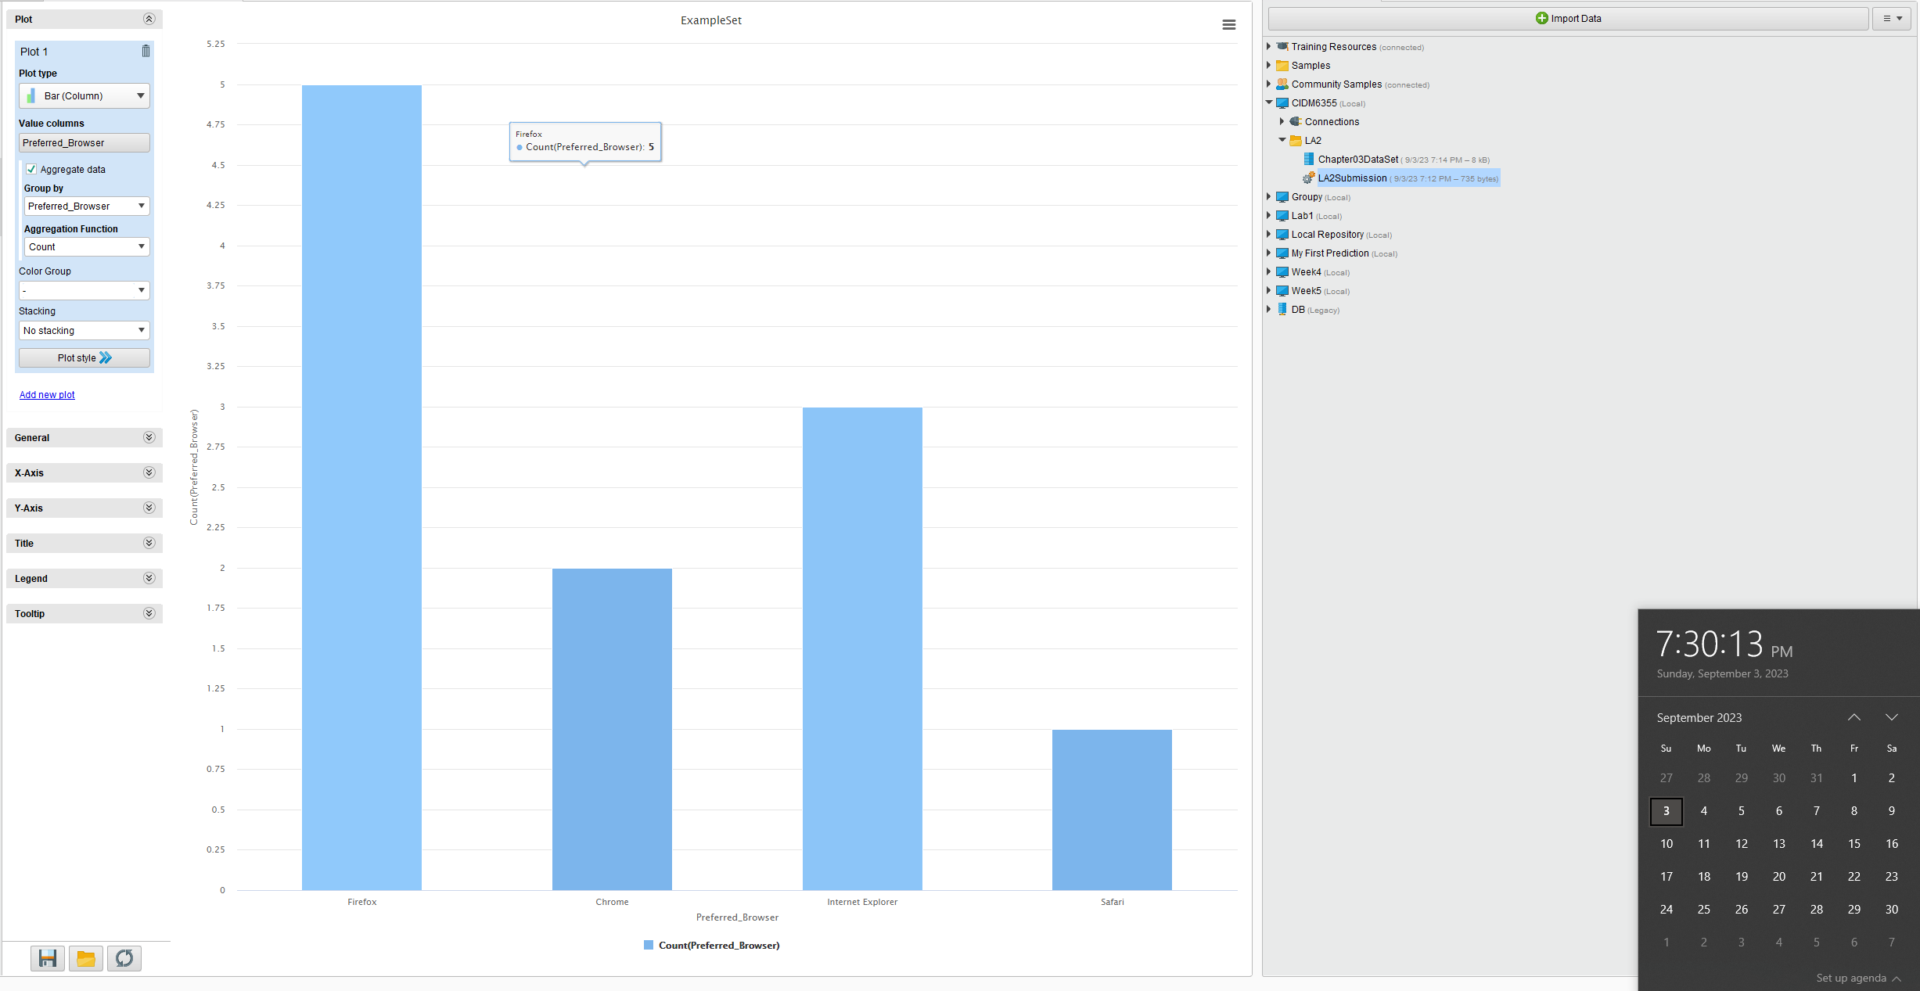

Description: Web browser preference (preferred browser) among 11 internet users. Below are results:

-Firefox: 5

-Chrome: 2

-Internet Explorer: 3

-Safari: 1

Firefox being the most preferred web browser.